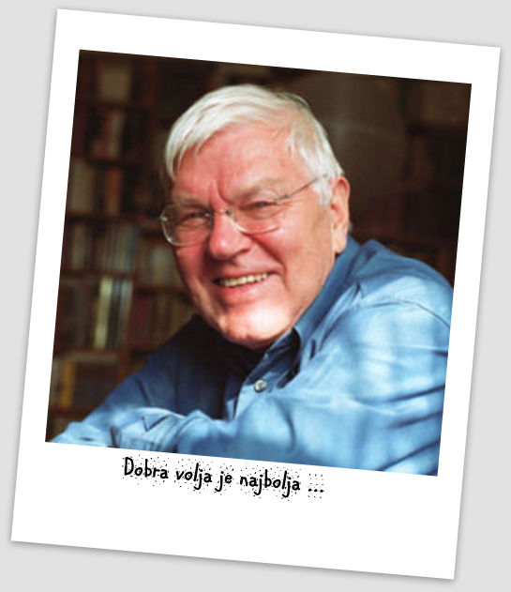
KAJETANU KOVIČU V SPOMIN
NAGRADNI KNJIŽNI KVIZ – JANUAR 2015
4. RAZRED
Rešen list prineseš v šolsko knjižnico do petka, 13. februarja 2015.

Rodil sem se v lepem mesecu oktobru v lepem mestu Mariboru
na Štajerskem. … moj oče ni nikoli maral strank in blokov in je
zame izbral neuvrščeno ime – Kajetan. To ime je bilo v tistih
časih in še dolgo potem nenavadno. (Zgodnje zgodbe, 1978)

Kajetan Kovič je umrl 7. novembra 2014 star 83 let. (Bil) je eden najbolj priljubljenih slovenskih mladinskih pisateljev in pesnikov. Njegove literarne junake pozna (skoraj) vsak slovenski otrok.
Jih prepoznaš tudi ti?
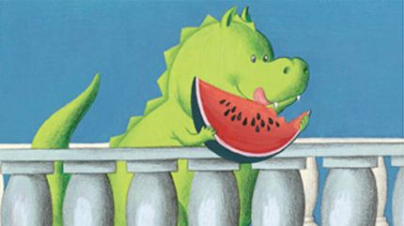
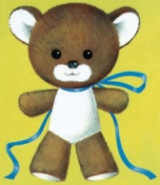
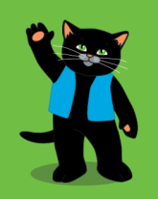
- Pod slike napiši imena Kovičevih literarnih junakov. Če jih ne prepoznaš, jih poišči v šolski knjižnici.

_______________ ________________ ________________________________ _______________ ________________ ________________________________
- Če pravilno povežeš naslove pesmic in črke vneseš v rešitev, boš dobil –a naslov še ene knjige, ki jo je napisal Kajetan Kovič.
1 | Križem | A | ladja
2 | Zlata | C | mož
3 | Zvezdo | K | zvonec
4 | Sneženi | E | šola
5 | Medvedja | N | kašopihec
6 | Šolski | P | kraž
7 | Franca | Č | Čombe
8 | Mihec | I | izpod klanca
9 | Kako se | J | plovec
10 | Maček | U | vrtijo ure

1 | 2 | 3 | 2 | 4 | 5 | 6 |  | 7 | 8 |  | 1 | 9 | 8 | 10 | 6 | 2
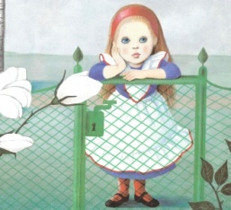
- Dobro si oglej sličice in napiši svojo zgodbo.
____________________________________________________________________________________________________________________________________________________________________________________________________________________________________________________________________________________________________________________________________________________________________________________________________________________________________________________________________________________________________________
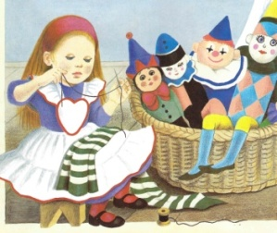
____________________________________________________________________________________________________________________________________________________________________________________________________________________________________________________________________________________________________________________________________________________________________________________________________________________________________________________________________________________________________________
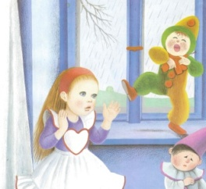
____________________________________________________________________________________________________________________________________________________________________________________________________________________________________________________________________________________________________________________________________________________________________________________________________________________________________________________________________________________________________________

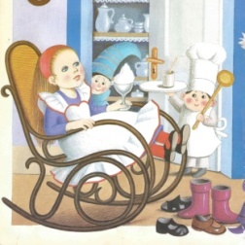
____________________________________________________________________________________________________________________________________________________________________________________________________________________________________________________________________________________________________________________________________________________________________________________________________________________________________________________________________________________________________________
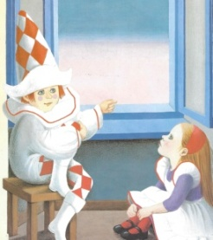
__________________________________________________________________________________________________________________________________________________________________________________________________________________________________________________________________________________________________________________________________________________________________________________________________________________________

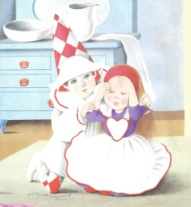
____________________________________________________________________________________________________________________________________________________________________________________________________________________________________________________________________________________________________________________________________________________________________________________________________________________________________________________________________________________________________________

Več o Kajetanu Koviču in njegovem ustvarjanju za otroke izveš, če obiščeš razstavo njegovih knjig v šolski knjižnici in/ali če obiščeš spletno stran šolske knjižnice http://branjejekul.weebly.com/knji382ni-kviz---januar-2015.html, kjer si lahko ogledaš tudi video posnetke.

